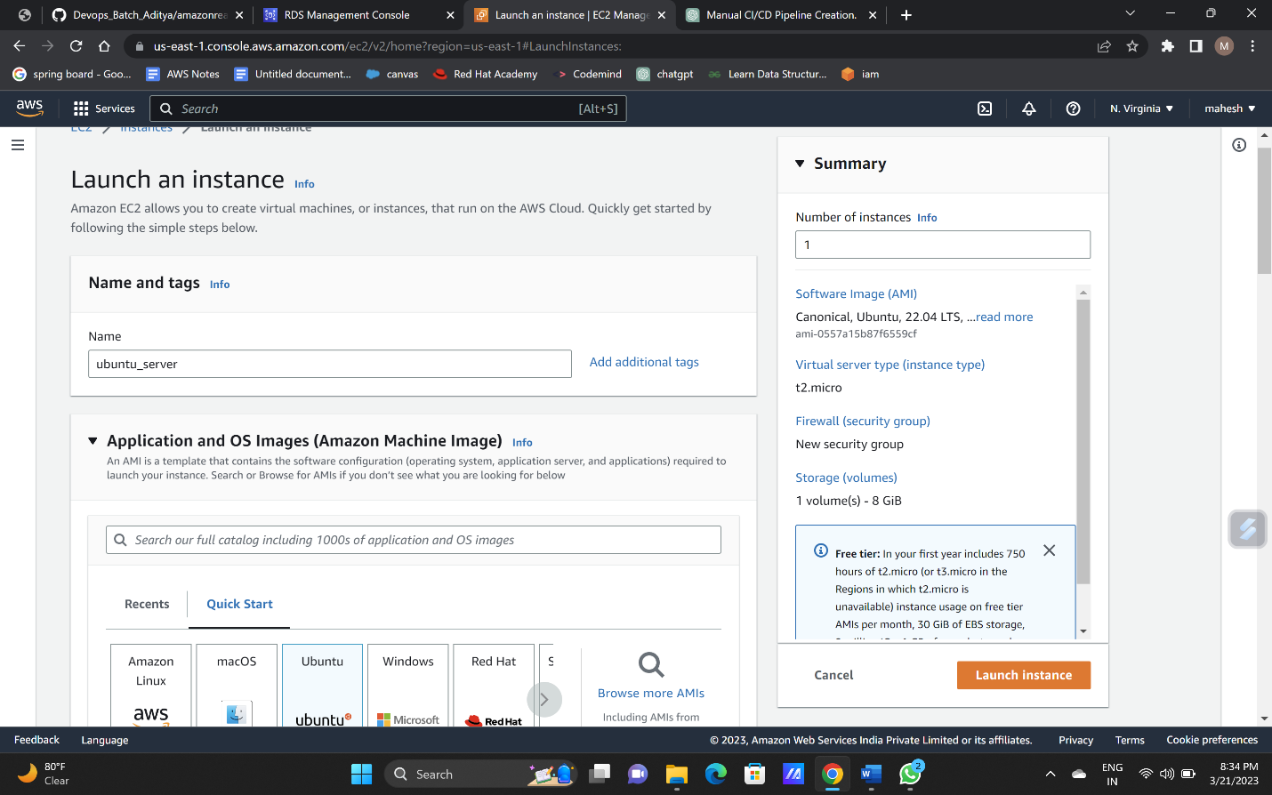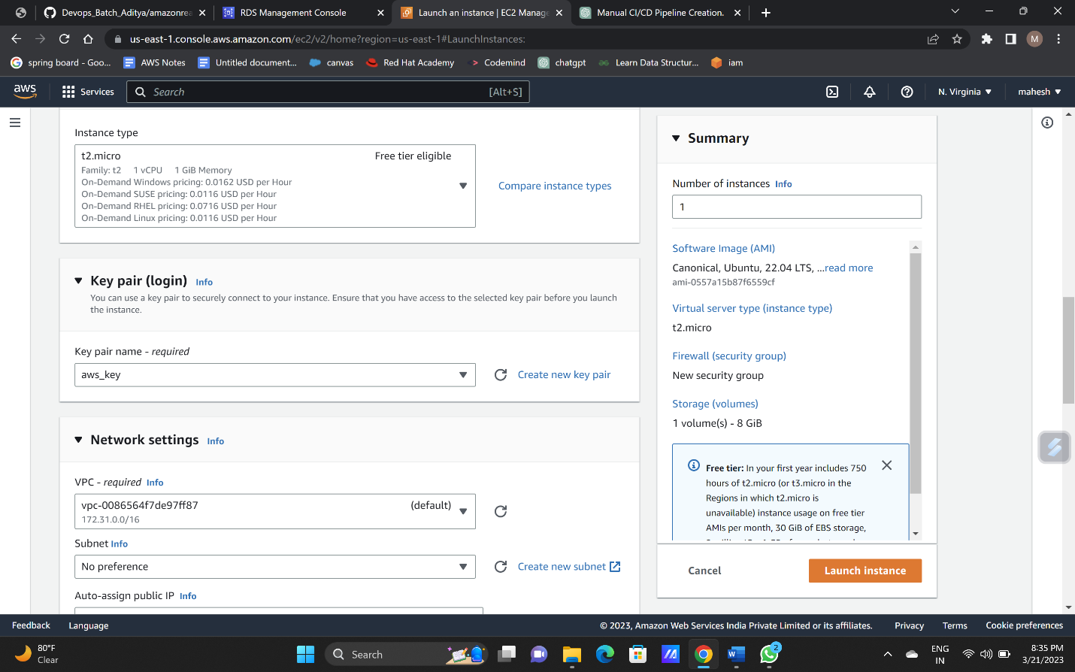**Creating ubuntu instance:**

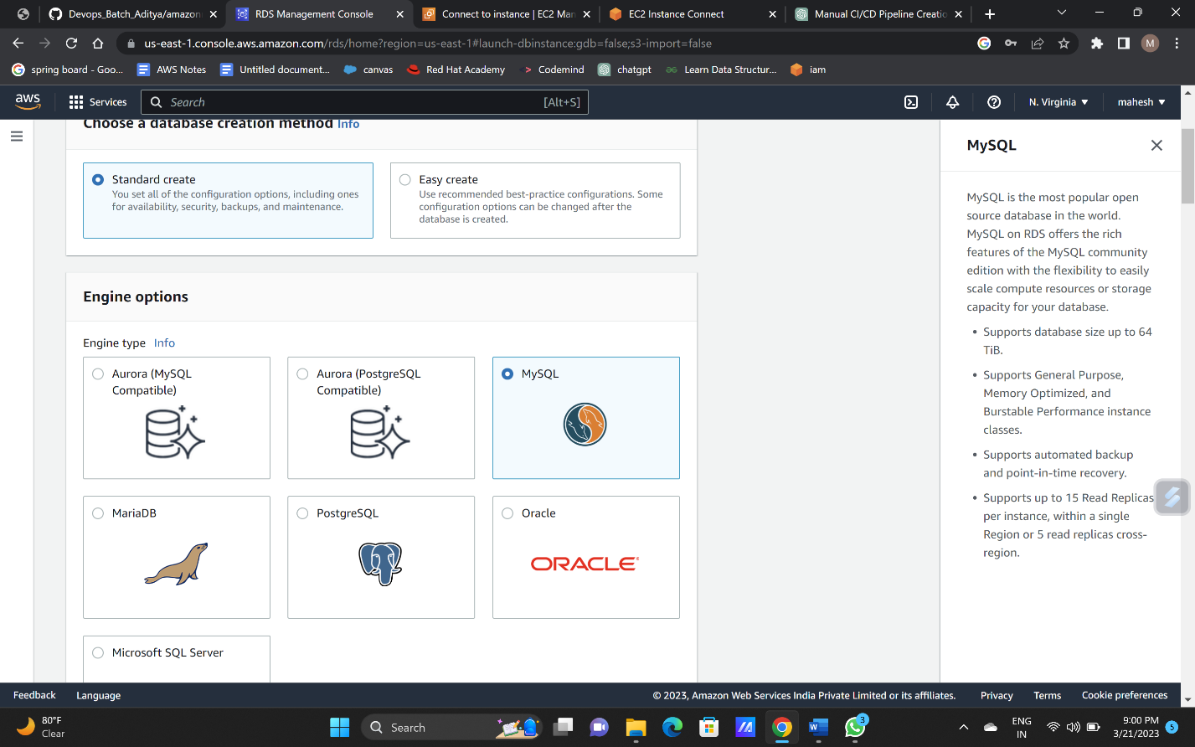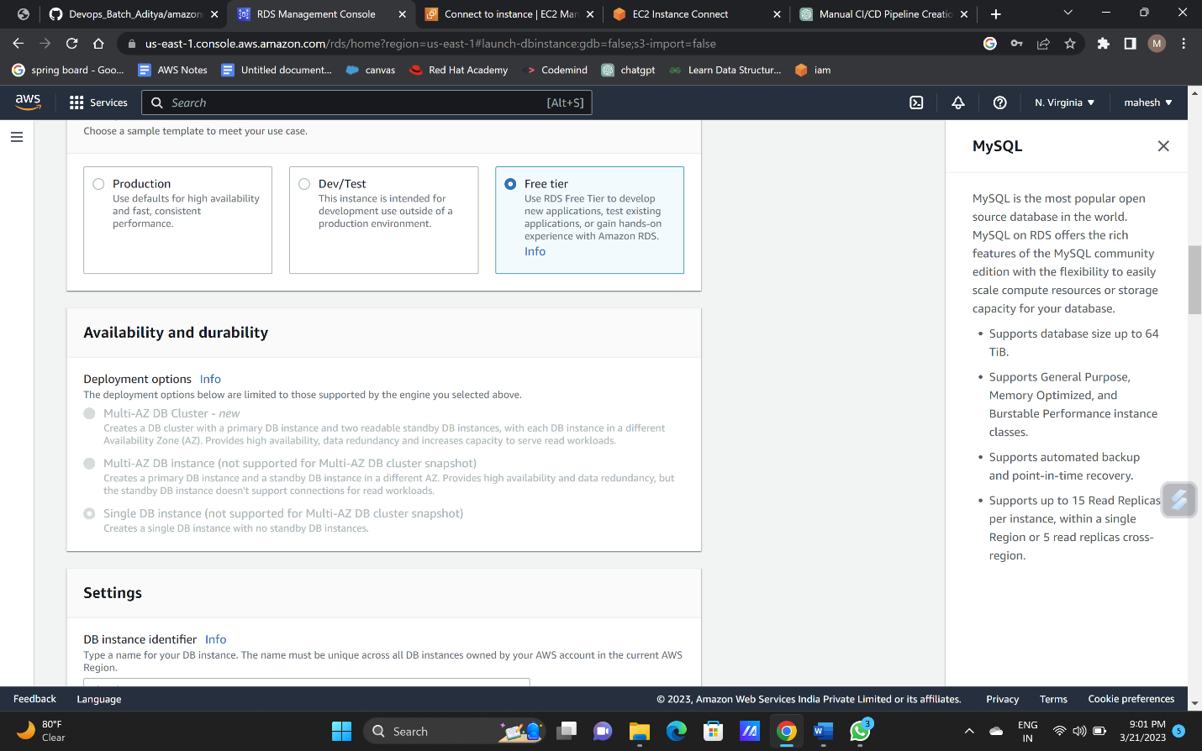**creating database**:

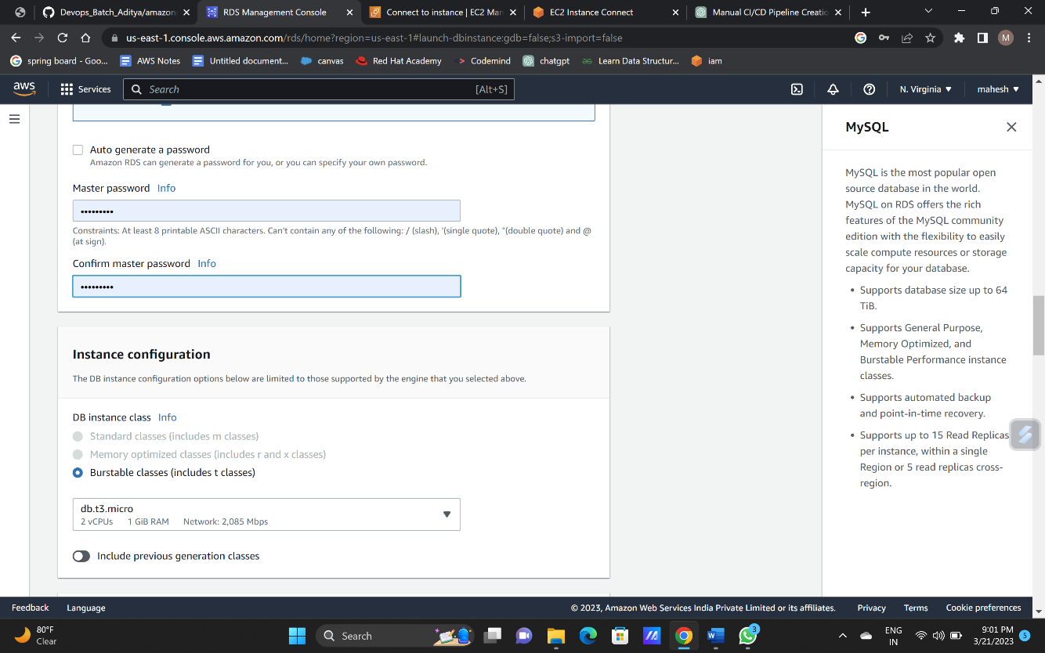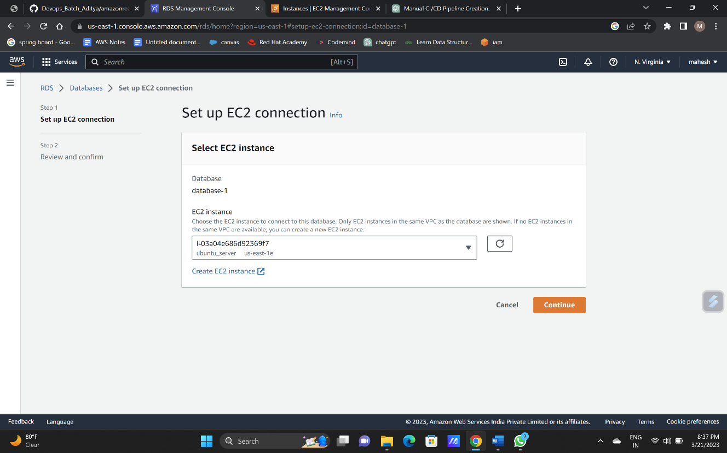

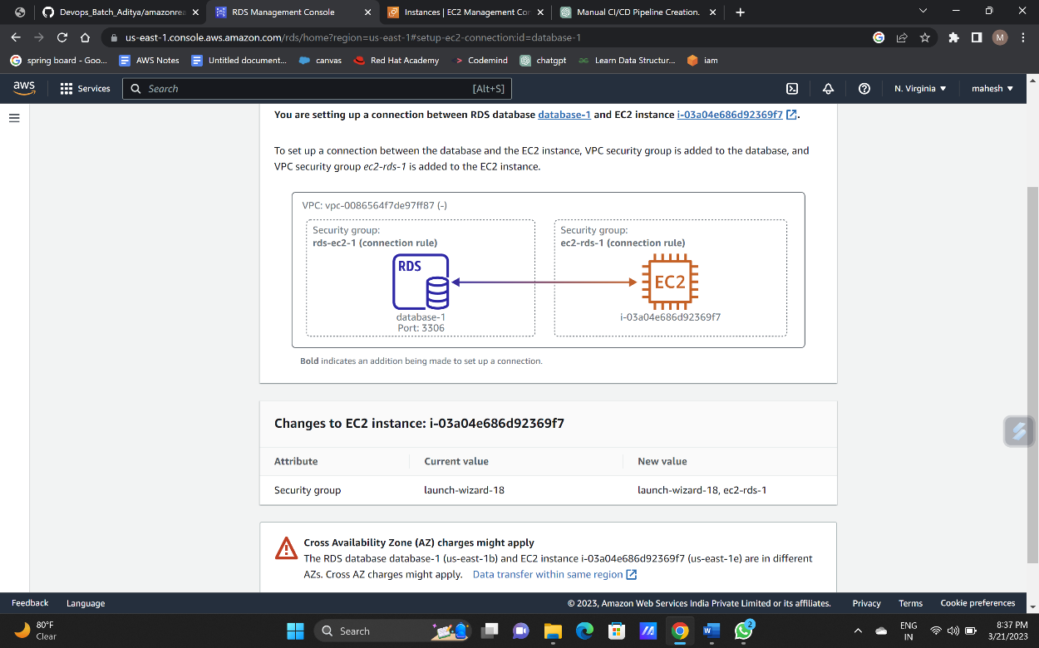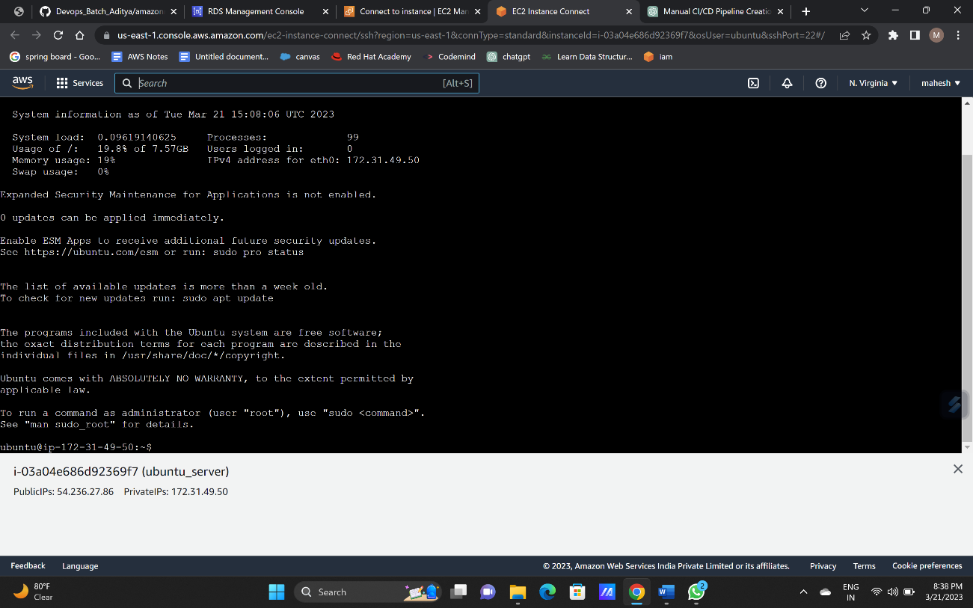**Connecting database and the ubuntu instance**:

Switch to root user “SUDO SU” and update “SUDO APT UPDATE”

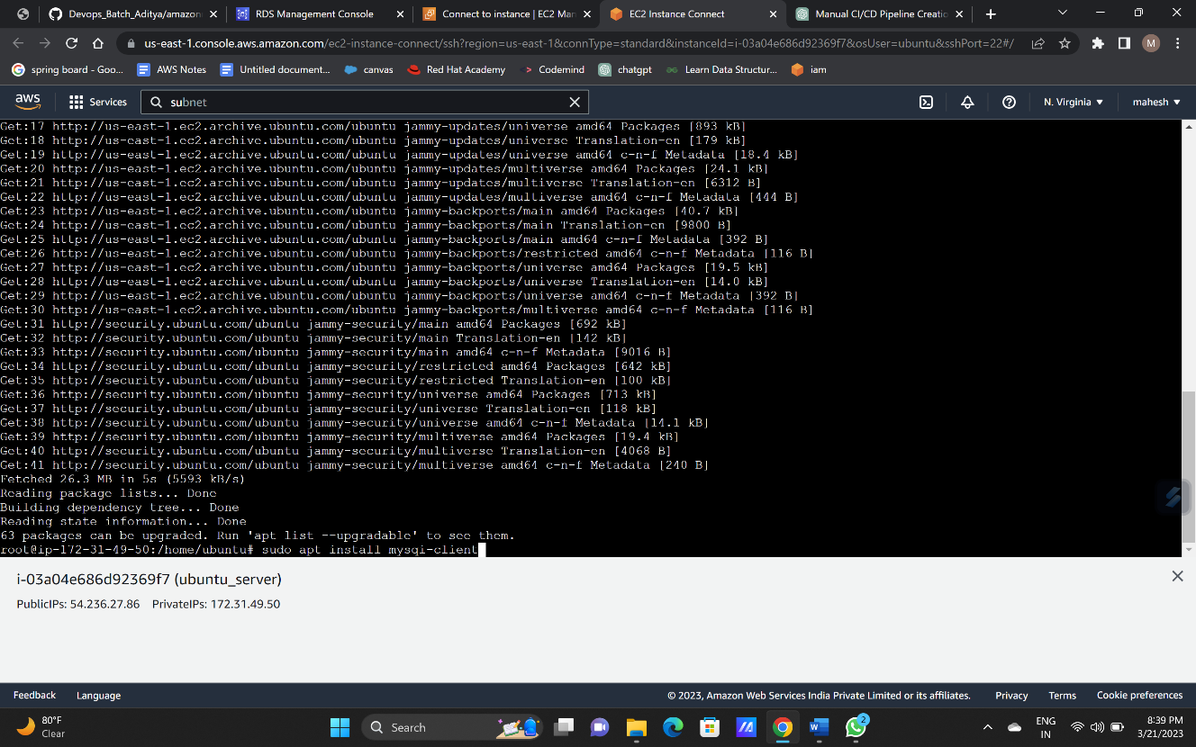

Install my sql using: “apt-get install mysql-client”

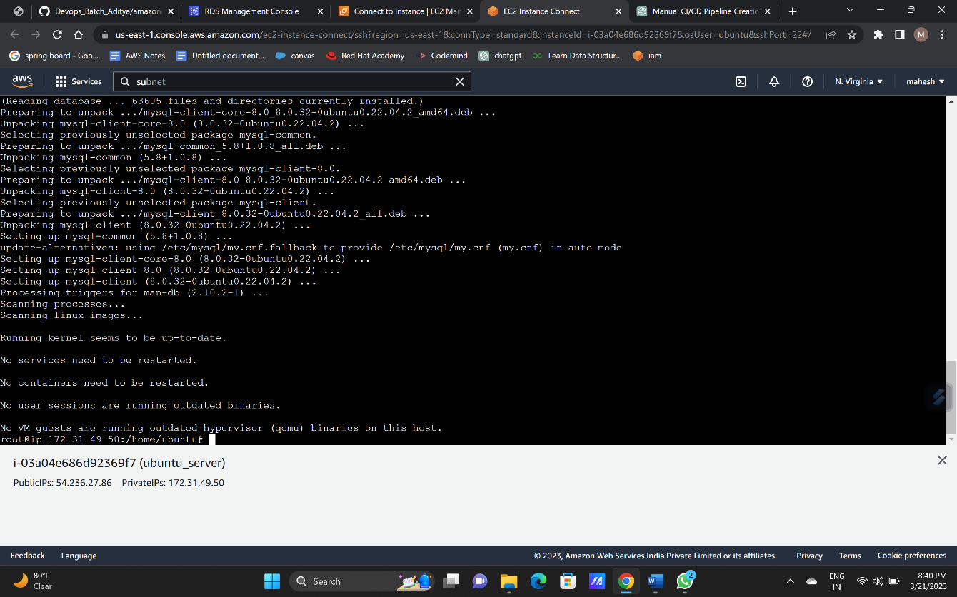

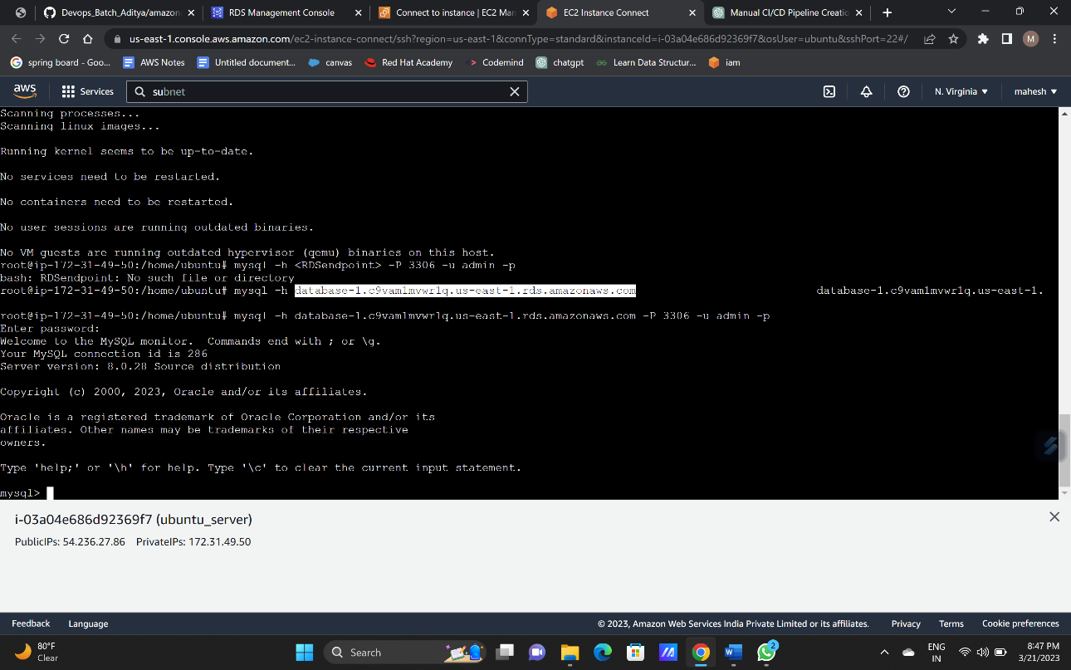connecting my sql to the database usibg command :” mysql -h <RDSendpoint> -P 3306 -u admin -p”

create the database and table into it using commands:

CREATE DATABASE <database_name>;

USE <database_name>;

CREATE TABLE <table_name> (id INT NOT NULL AUTO_INCREMENT, name VARCHAR(50) NOT NULL, PRIMARY KEY (ID));

INSERET INTO <table_name> (name) VALUES ('your name')

